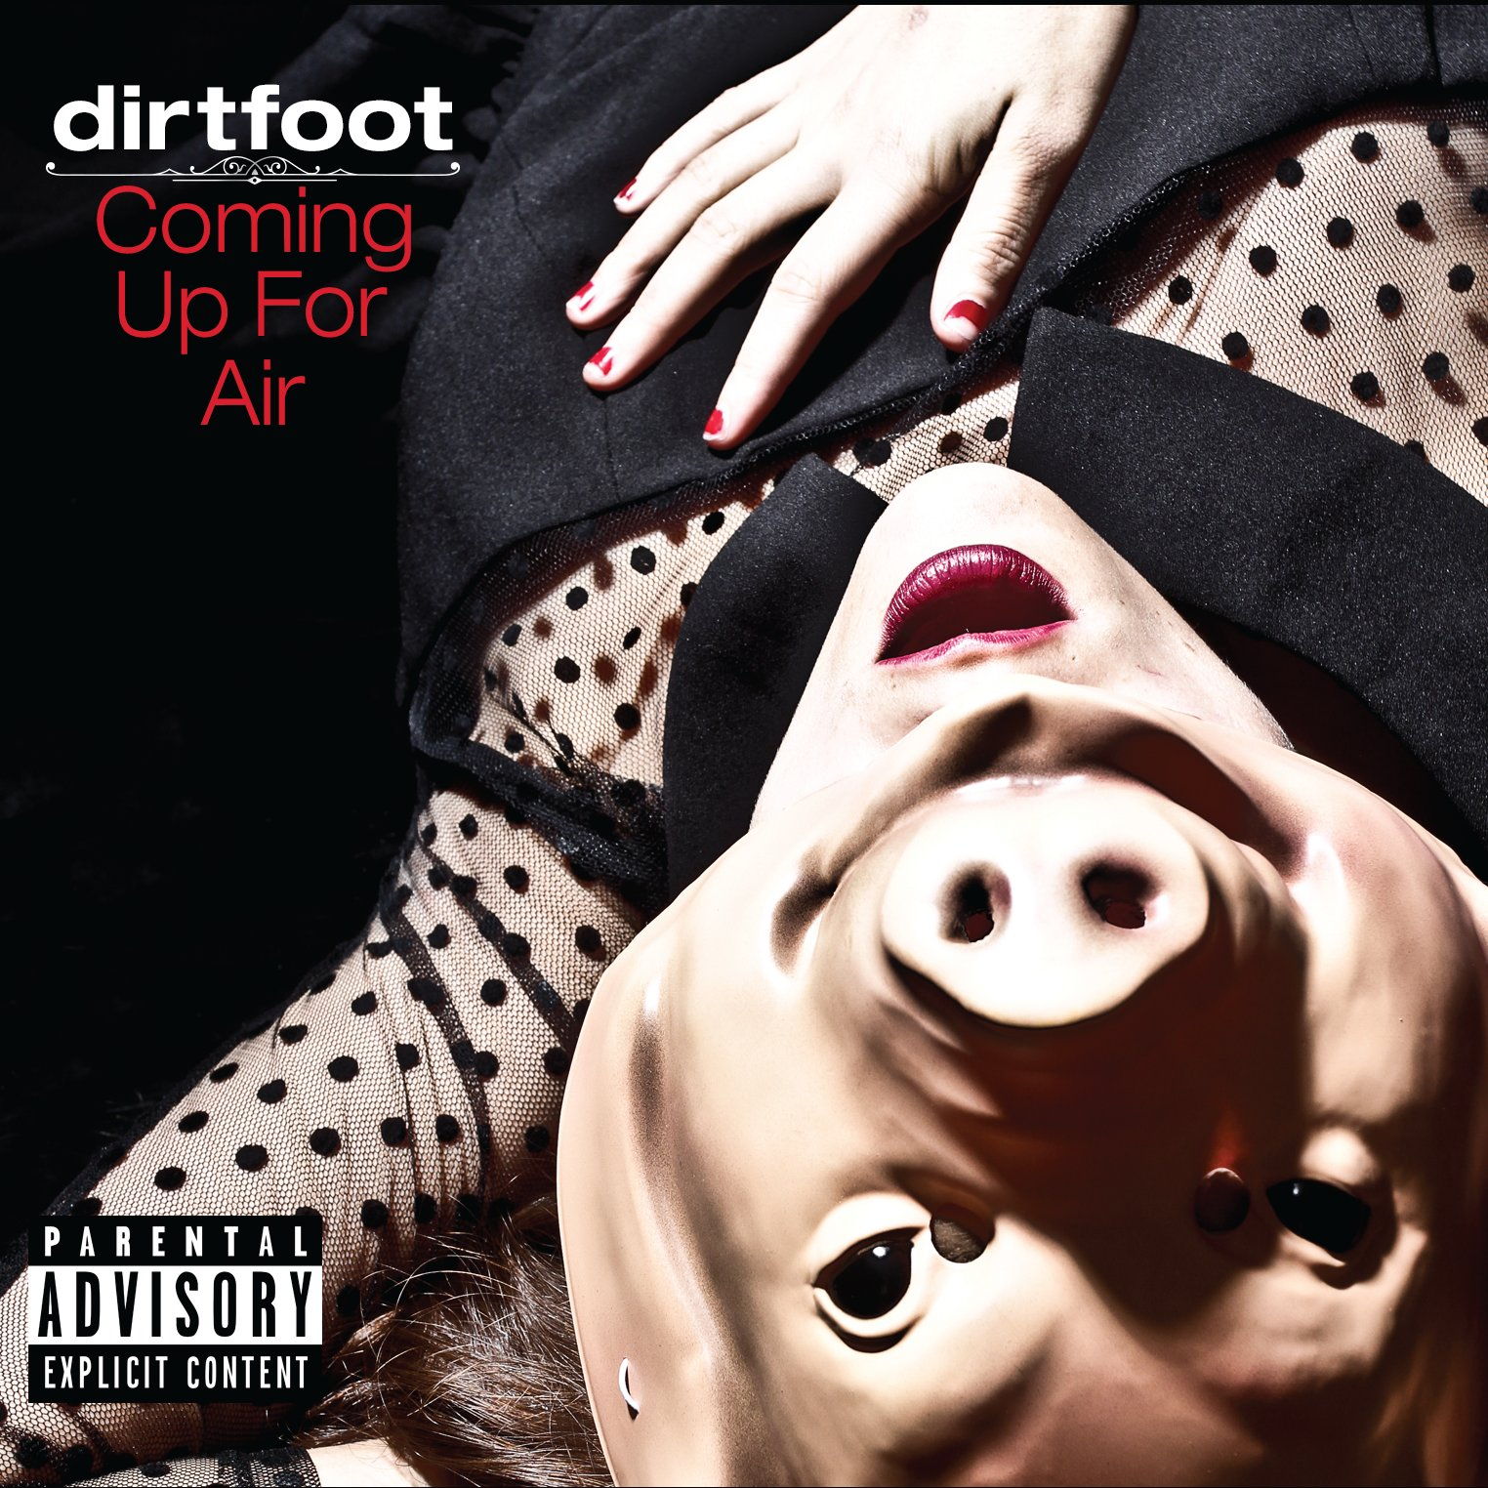

Dirtfoot is a raucous powerhouse, with high energy shows and enthusiastic crowds where people stomp their feet and yell like lunatics on a full moon night.

Whether performing on big stages at festivals, or playing intimate setting in the pubs and taverns, Dirtfoot puts on an uproarious show. The crowds come to take part in the fun and chaos, hollering to all the calls and responses, shaking their beancans, and getting down with the infectious grooves. There is only one Gypsy Punk Country Grumble Boogie band in the land… Dirtfoot.

“There’s no way Dirtfoot’s fourth album – Coming Up For Air – could have been recorded in the daylight. Oh, don’t get me wrong: the Shreveport, LA-based band will make you grin and dance and hoot and holler throughout the album’s 13 tracks – but there’s always a wee bit of darkness handy. Or weirdness. Or something. But it’s cool.” – Brian Robbins – jambands.com

"We. We run this town. Let's turn this motherf*cker upside down." Whether Dirtfoot's energy was planing off as the group enters its eighth year is answered by the album "Coming Up for Air." It snorts and rocks the trough like the guys have been delivered again. The above opening line, from their original "I am a man," sets the tone for an album that juggles steel cojones.” – Robert Trudeau

“As Thursday night turned into Friday morning‚ I came across the biggest surprise of the weekend. I eagerly stood and shook my bones to the tantalizing sounds. It was dirty. It was claustrophobic. It was voodoo rock as fire dancers twirled around the stage. Their mix of psychobilly‚ blues and funk had my underwear all in a twist as I danced with reckless abandon.” G Woodward – TheRFW.com

“Imagine Nick Cave on a bed of rusty nails, the cover of “Gin and Juice” often mis-attributed to Phish (it was actually the Gourds), some old-timey “Dem Bones,” Old Crow Medicine show culture-clash, and that subtle fecal stench of Mr. Bungle skronk sax craziness: Get theses elements, let them stew in an oaken barrel for a number of years and out comes Shreveport, Louisiana’s Dirtfoot.” – Spencer – Synthesis.net

Key Points:

- Currently recording 4th Studio album to be released late 2017
- Added Horn Player and musician extraordinaire, Doug Dicharry to the lineup.
- “Coming Up for Air” named Finalist in the IMA’s Alt Country Album Categ.
- Nov 5, 2013 release of new album “Coming Up for Air” recorded at Blade Studios feat. Papa Mali, Rebirth Brass Band & funded via Kickstarter ($20K)
  - Engineered by Chris Bell (The Eagles, Erykah Badu)
  - Mastered by Gavin Lurssen (Tom Waits, T Bone Burnett)
- Named Finalist in 2013 IMA’s Alt Country Album Category
- Selected Artist for the “Louisiana Music Ambassador Project”
- Won Independent Music Awards Vox Populi Comp for Short Video - 2012
- Live Album and Live DVD – “Dirtfoot Live and in Prison” released Dec 23, 2011 – Including Vinyl. Recorded at local prison in front of 300 inmates. Funded via Kickstarter ($16K)
- Grand Prize Winner -John Lennon Song Writing Comp – NOLA Jazz Contest
- Album “Bone Sessions” released Nov 22, 2008
  - Engineered by Chris Bell (The Eagles, Erykah Badu)
  - Mastered by Gavin Lurssen (Tom Waits, T Bone Burnett)
- “Entertain Me” First album released Dec 2006.
- Named Finalist in the 8th & 9th Annual Independent Music Awards – Alt Country Song Category.
- Filmed episode of PBS Series “Music Voyager” – Jan 2010
- Song “Devil Don’t Care” featured on PBS series “Roadtrip Nation”
- Featured in online TV Episode of “Groovable Feast” 12/29/2010
- Opened for: Primus, The Band Perry, Meat Puppets, Rev Horton Heat, Cracker, Southern Culture on the Skids, Cowboy Mouth, The Wood Brothers, Rebirth Brass Band, Col. Bruce Hampton, Lucero
“A Dose of Gypsy Punk Country Grumble Boogie”

Track Listing:
- I Am a Man
- Hypocrisy
- Sweet Love
- I’m Going Home
- No Good Man
- Giving Up on Love
- This Old Pride
- Break My Bones
- Right To Breathe
- John Zooke
- Heroin
- Amelia Earhardt
- Underwater Turtle

Performances include:
- Events: Highberry Music Fest – 2015-17, Hillberry Music Fest 2015-17, Pedalers Jamboree 2014, 15, 17, Wakarusa Music Festival 07,08,09,10,11,12,13,14, 15 - Mulberry Mountain Harvest Festival 07,08,09,10,11,12,13,14 Phases of the Moon 2015, Revival Fest 2015, All Good Music Fest 2012, Summercamp 2011, Opening 5 nights with Primus May, 2011, Opening 12 nights with Rev Horton Heat Jan-Feb 2011, Voodoo Music Experience 07

Extra Credit:
- Official Site - www.dirtfoot.com
- Facebook - Currently 8000+ Likes
- Twitter – Currently 1200+ followers
- Youtube – Music Video “Cast My Plans” 18000+ views
- Contact – J Bratlie – guandhank@gmail.com
318-560-1466



